# Preventing Heat-related Illness

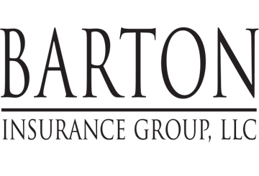

Be safe and healthy on the job at **Evolution Maintenance, Inc** with these helpful tips provided by **Barton Insurance Group LLC.**

Heat syncope is fainting or dizziness that occurs from prolonged standing in hot weather. Avoid this by staying hydrated throughout the workday, even if you don’t feel thirsty.

This flyer is for informational purposes only and is not intended as medical or legal advice.

© 2009-2010, 2017 Zywave, Inc. All rights reserved.

.

## Helpful tips for beating the summer heat

Summer heat can be more than uncomfortable; it can be a threat to your health. Unfortunately, you do not have much of a choice when it comes to job site. Follow these tips to stay safe in the searing heat.

**Heat Exhaustion**

Heat exhaustion occurs when a person cannot sweat enough to cool the body—usually the result of not drinking enough fluids during hot weather. Symptoms include:

* Dizziness, weakness, nausea, headache and vomiting
* Blurry vision
* Body temperature rising to 101° F
* Sweaty skin
* Feeling hot and thirsty
* Difficulty speaking

A person suffering from heat exhaustion must move to a cool place and drink plenty of water to avoid a more severe heat-related condition—heat stroke.

**Heat Stroke**

Heat stroke is the result of untreated heat exhaustion. Symptoms include:

* Sweating stops
* Unawareness of thirst and heat
* Body temperature rising rapidly to above 101° F
* Confusion or delirium
* Possible loss of consciousness or seizure

Heat stroke is a serious medical emergency that must be treated quickly by a trained professional. Until help arrives, cool the person down by placing ice on the neck, armpits and groin. If the person is awake and able to swallow, have them drink a small glass of water every 15 minutes or until help arrives.

**Tips for Staying Cool**

The combination of heat and humidity in the summer months can be downright uncomfortable and even dangerous. Stay cool by following these safety tips:

* Drink plenty of water—enough water to quench your thirst. The average adult needs eight 8-ounce glasses of water a day, and even more during hot weather.
* Skip the caffeine and soda; drink water instead.
* Dress for the weather. When outside, wear lightweight clothing of natural fabric and a well-ventilated hat.
* Eat light. Replace heavy or hot meals with lighter, refreshing foods. And always eat smaller meals before work or intense activity.